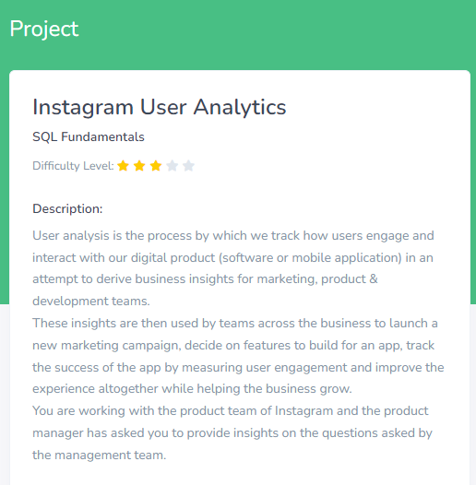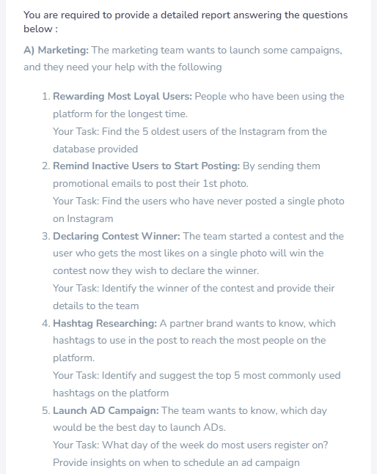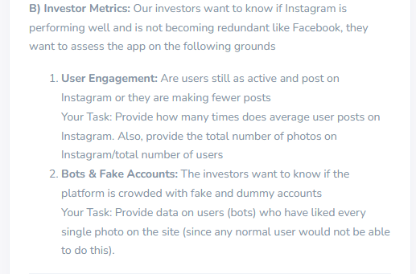

**INSTAGRAM USER ANALYTICS**

**A)MARKETING**

**1)Rewarding Most Loyal Users**

SELECT * FROM users ORDER BY created_at ASC LIMIT 5;

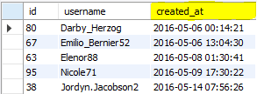

2)**Remind Inactive Users to Start Posting**

SELECT u.* FROM users u LEFT OUTER JOIN photos p ON u.id=p.user_id WHERE p.user_id IS NULL; 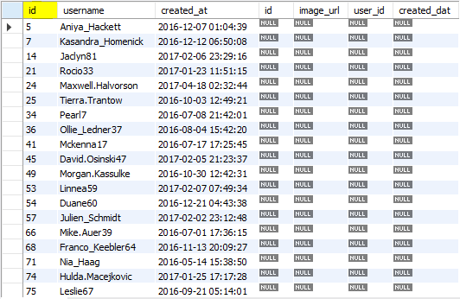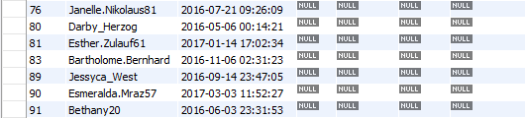

**3)Declaring Contest Winner**

SELECT users.username,users.created_at,user_id,photo_id,count(*) AS num_of_most_liked FROM likes INNER JOIN users ON users.id=likes.user_id GROUP BY photo_id ORDER BY num_of_most_liked DESC LIMIT 1;



**4)Hashtag Researching**

SELECT tags.tag_name,tag_id,count(*) AS count_of_hashtags FROM photo_tags INNER JOIN tags ON tags.id=photo_tags.tag_id GROUP BY tag_id ORDER BY count_of_hashtags DESC LIMIT 5;

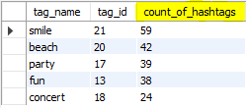

**5)Launch AD Campaign**

SELECT created_at,count(id) AS number_of_register FROM users GROUP BY MONTH(created_at) ORDER BY number_of_register DESC;

**NOTE:The highlighted day is the most registered day by the users, so the best day to schedule the ad campaign is 2016-10-05.**

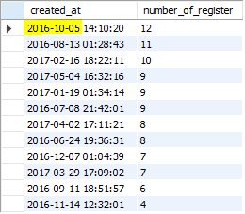

**B)INVESTOR METRICS**

**1)User Engagement**

SELECT DISTINCT user_id,count(id) AS Each_user_posted FROM photos WHERE created_dat<date_sub(now(),INTERVAL -12 MONTH) GROUP BY user_id;

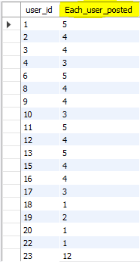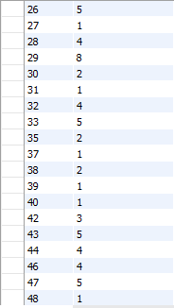

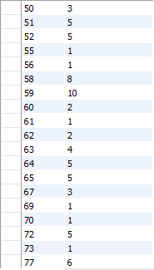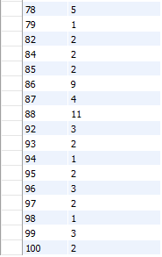

SELECT count(id) / count(DISTINCT user_id) AS Average_photos_posted_by_user FROM photos;



**2)Bots & Fake Accounts**

SELECT user_id,photo_id,count(user_id) AS tot_likes FROM likes GROUP BY user_id ORDER BY tot_likes desc;

